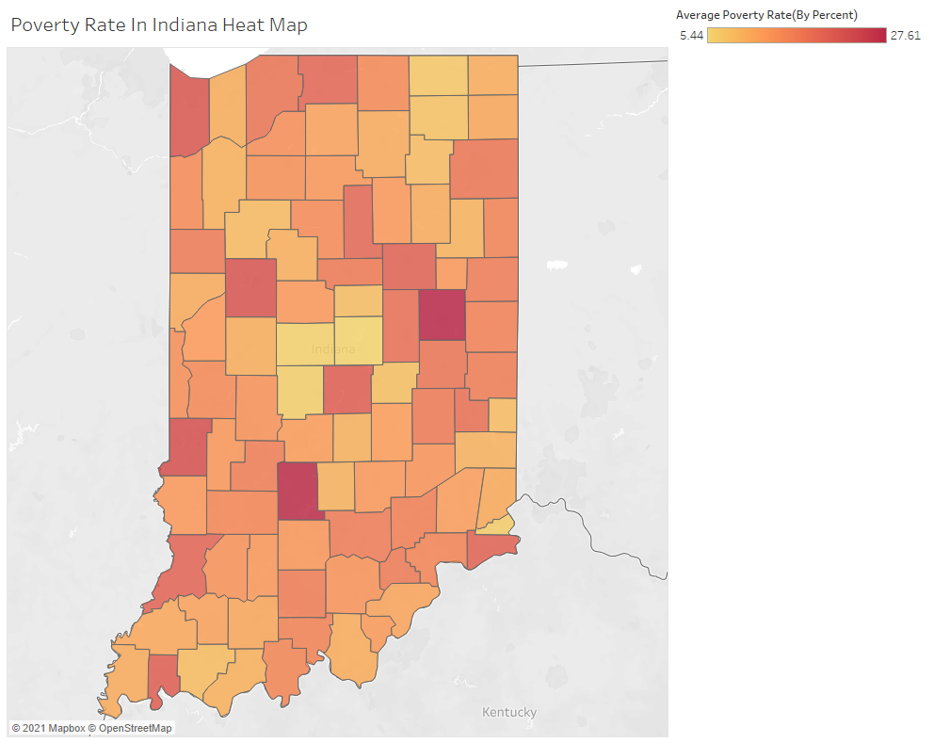

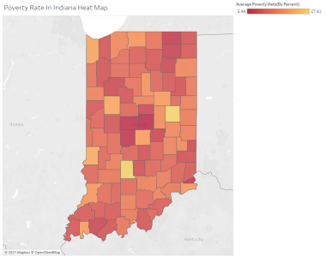

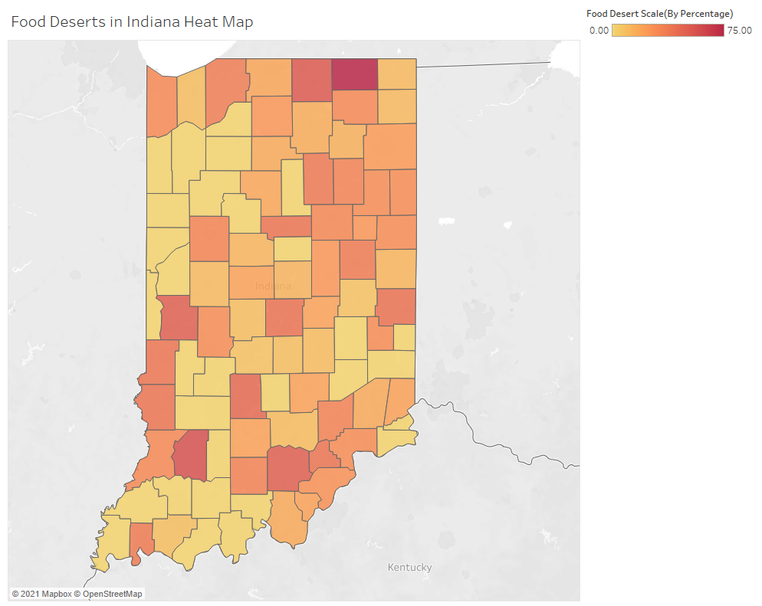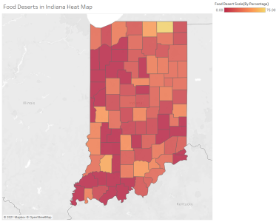

The colors were reversed in both cases to better illustrate to the viewer the distribution of poverty rate and food deserts throughout Indiana. It is easier for the eye to be drawn to the dark red spots amongst bright colors rather than bright spots amongst dark red colors. Red is also more associated with negative attributes, and is better suited to highlight these areas.